* **MATRICES ADDITION**
  + To add two matrices: add the numbers in the matching positions:

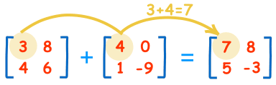

These are the calculations:

|  |  |
| --- | --- |
| 3+4 = 7 | 8+0 = 8 |
| 4+1= 5 | 6−9 = −3 |

* + The two matrices must be the same size, i.e. the rows must match in size, and the columns must match in size.
  + Example: a matrix with **3 rows** and **5 columns** can be added to another matrix of **3 rows** and **5 columns**.
  + But it could not be added to a matrix with **3 rows** and **4 columns** (the columns don't match in size)

**Negative**

* The negative of a matrix is also simple:

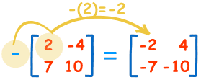

These are the calculations:

|  |  |
| --- | --- |
| −(2) = −2 | −(−4) = +4 |
| −(7) = −7 | −(10) = −10 |